Date as Postmark
Dear Applicant
Re: Manager Post- 37hrs. Closing date: 15th February 2021
Thank you for your interest in the above post.
You will find enclosed:-
- Job Application Form
- Job Description
- Person Specification
- Equality & Diversity Monitoring Form (Optional)

Please return your completed Application Form and the Equality & Diversity Monitoring Form in an envelope clearly marked Private & Confidential to Mr Aziz Daji (Chair) at the above address or via email to chair@milen.org.uk before the closing date.
Only shortlisted candidates will be notified of the result of their application. If you have not heard from us, within four weeks of the closing date, please assume that, on this occasion, your application has not been successful.
Please read the Job Description and Person Specification carefully and try and identify any experience you may have. This does not have to be work related but could be in a voluntary capacity which is relevant to the post. Pease do use the additional information section to support your application. Short listing will be carried out based on the information you provide.
Please enclose a stamped, self-addressed envelope if you wish us to acknowledge receipt of your application.

Yours faithfully
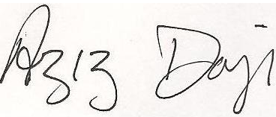
Aziz Daji
Chair

Enc.

